Australia’s Physical Features

Coral Sea

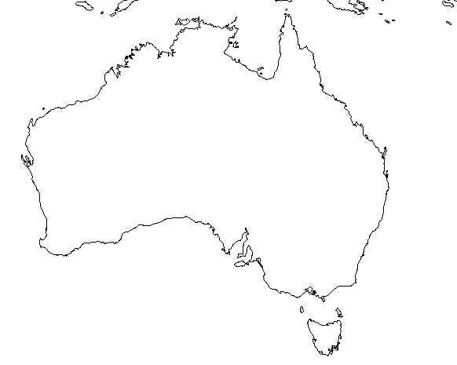

Great Barrier Reef

Great Victorian Desert

Ayers Rock